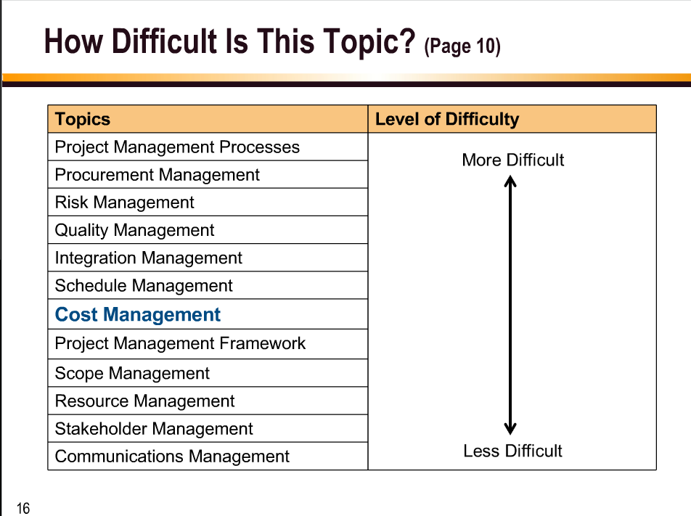

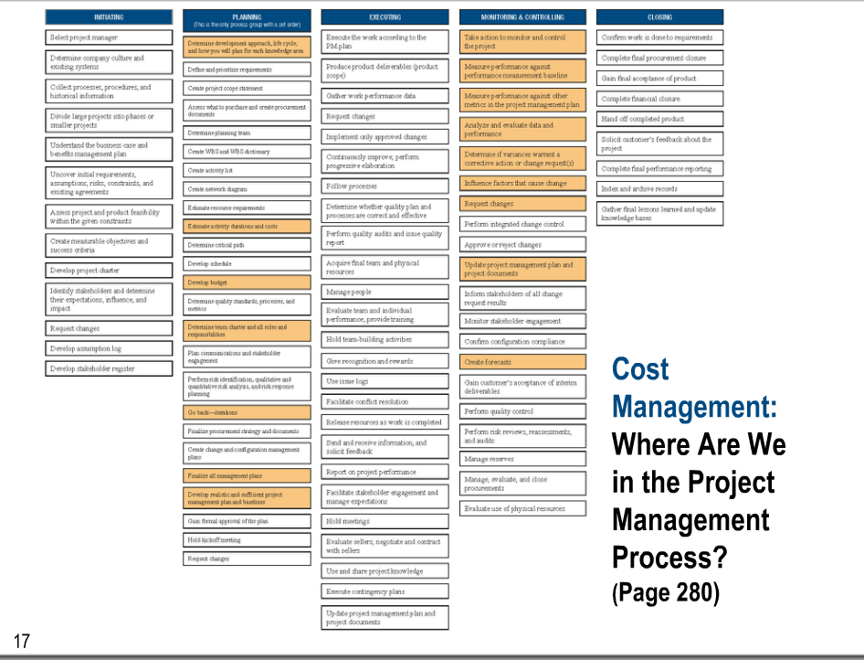

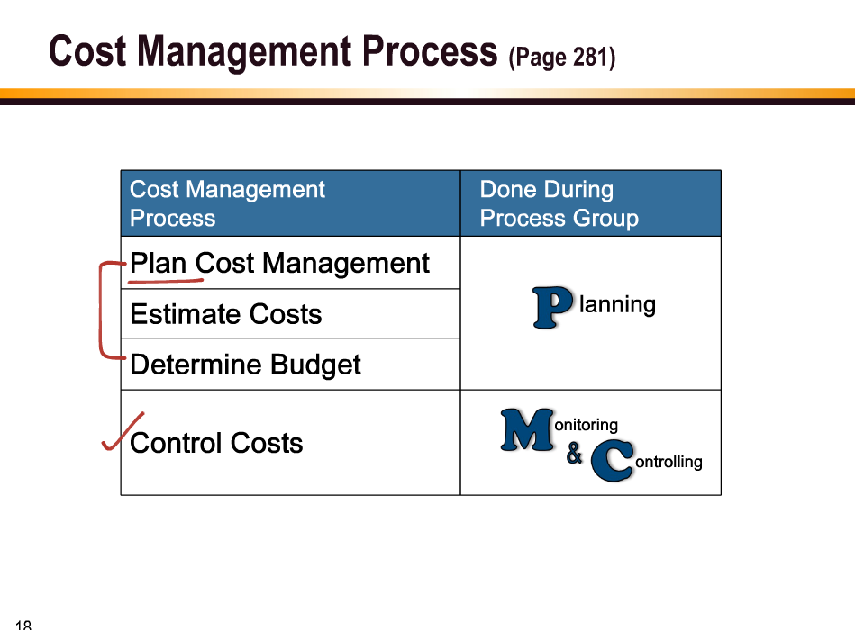

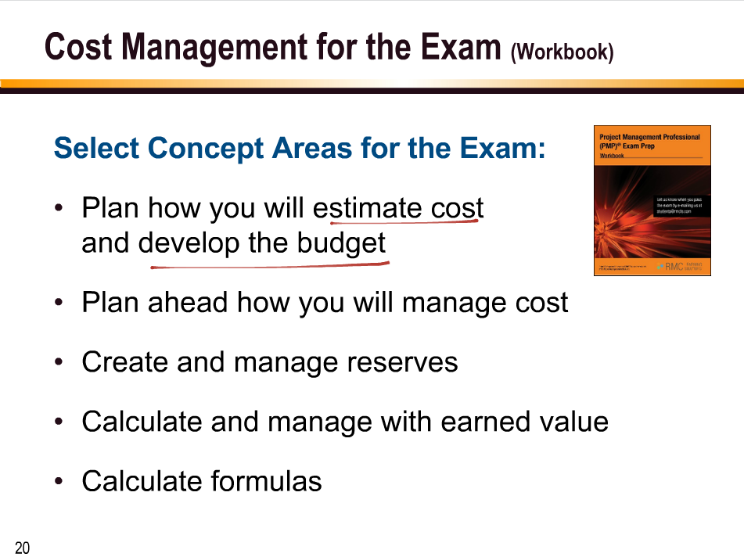

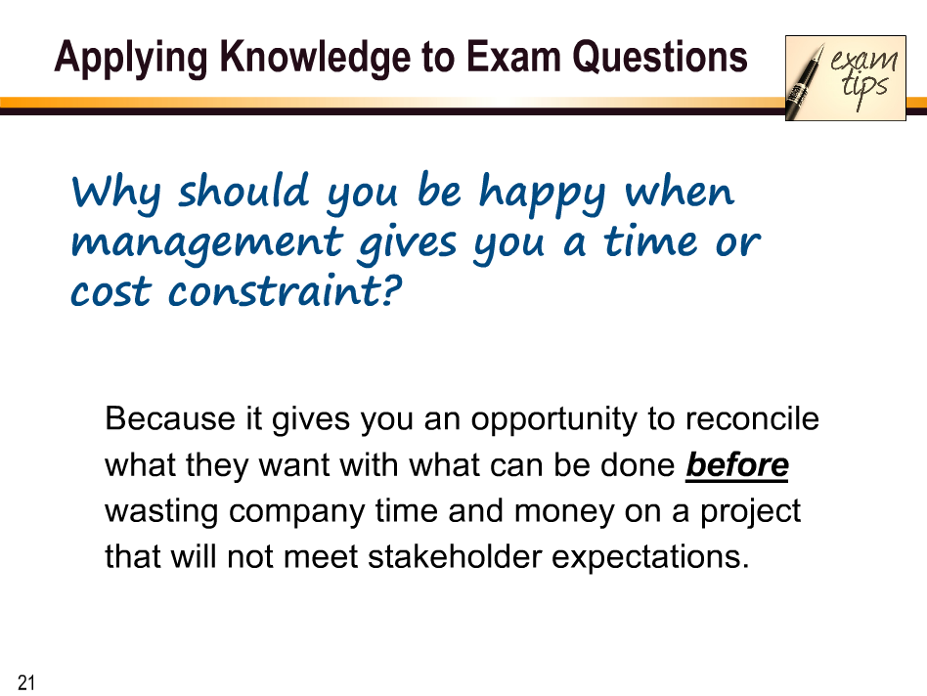

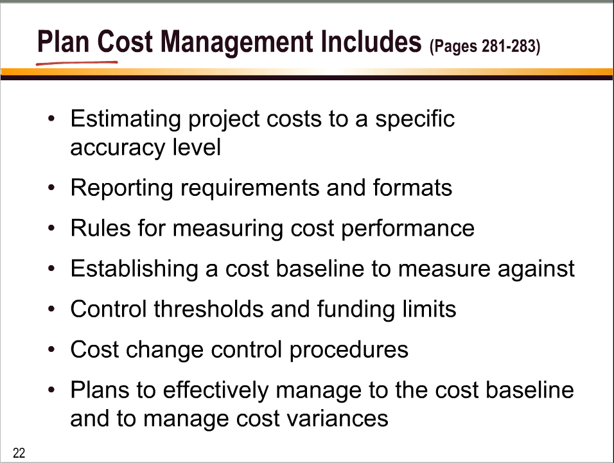

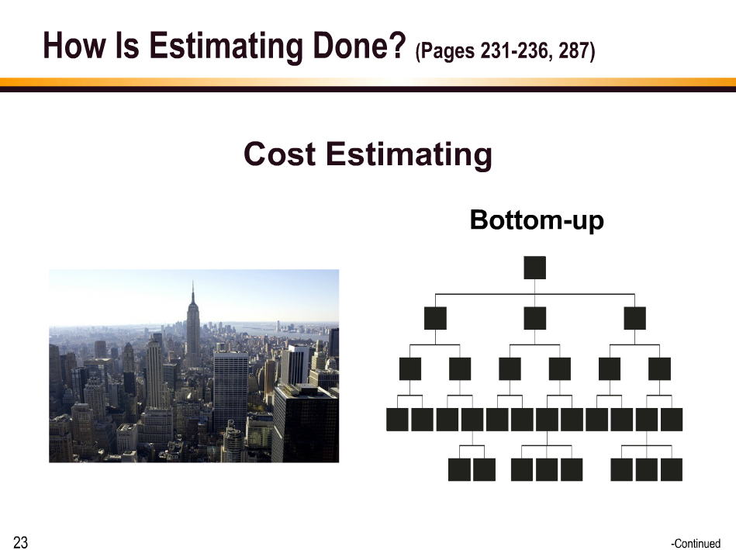

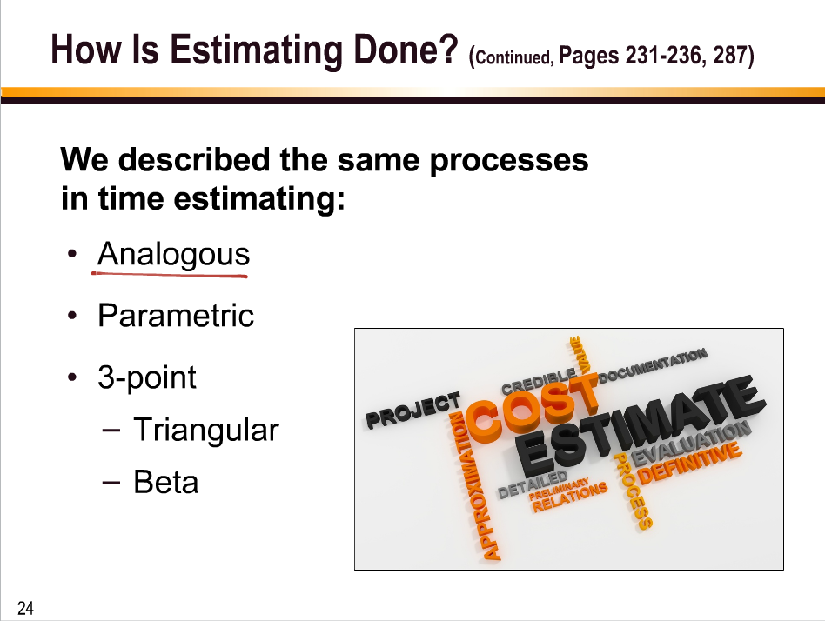

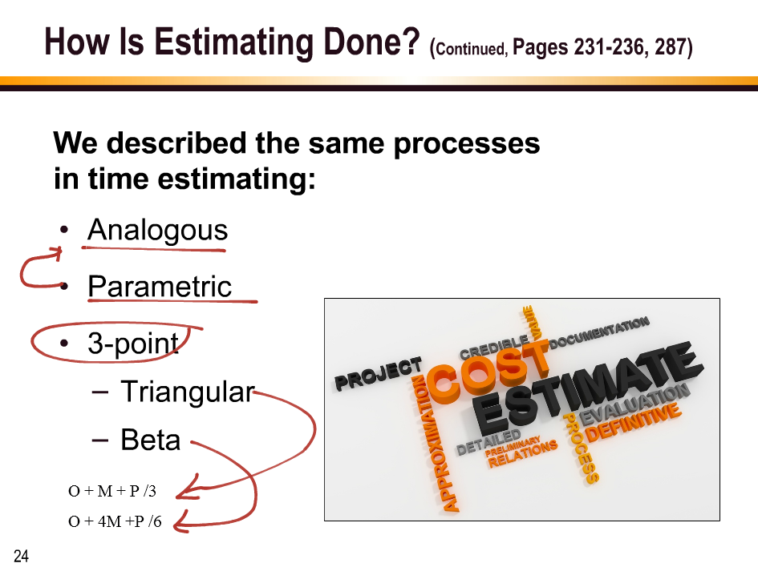

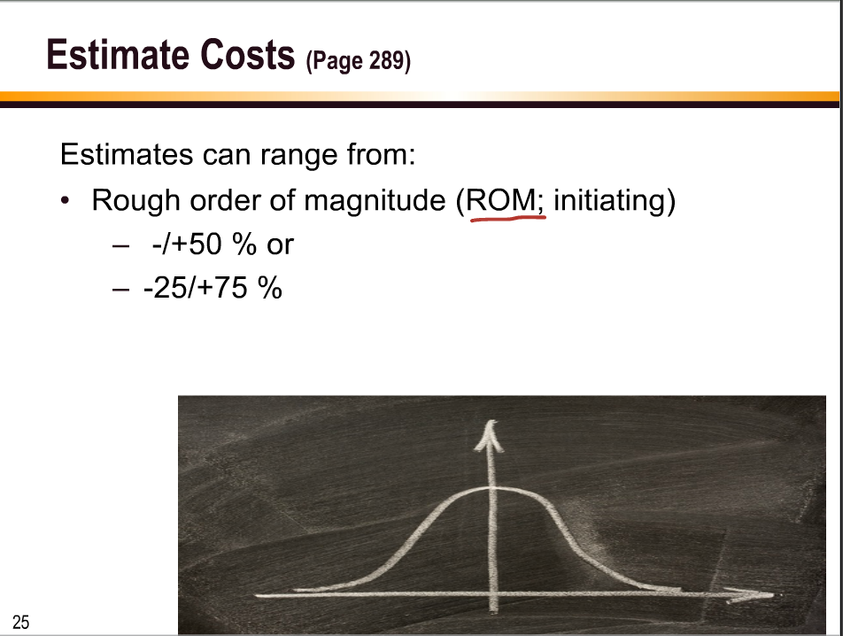

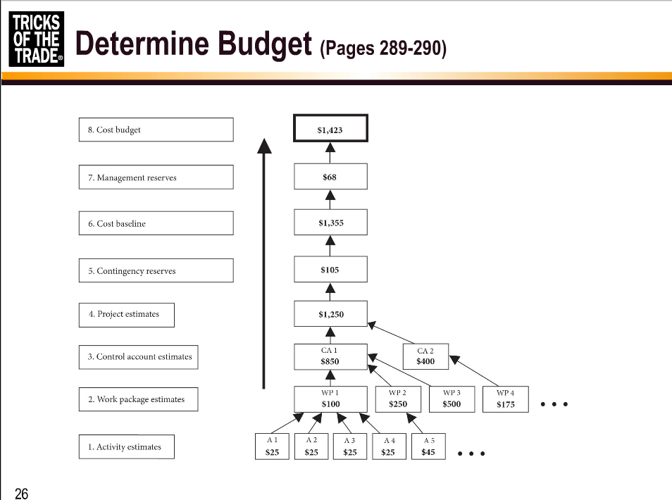

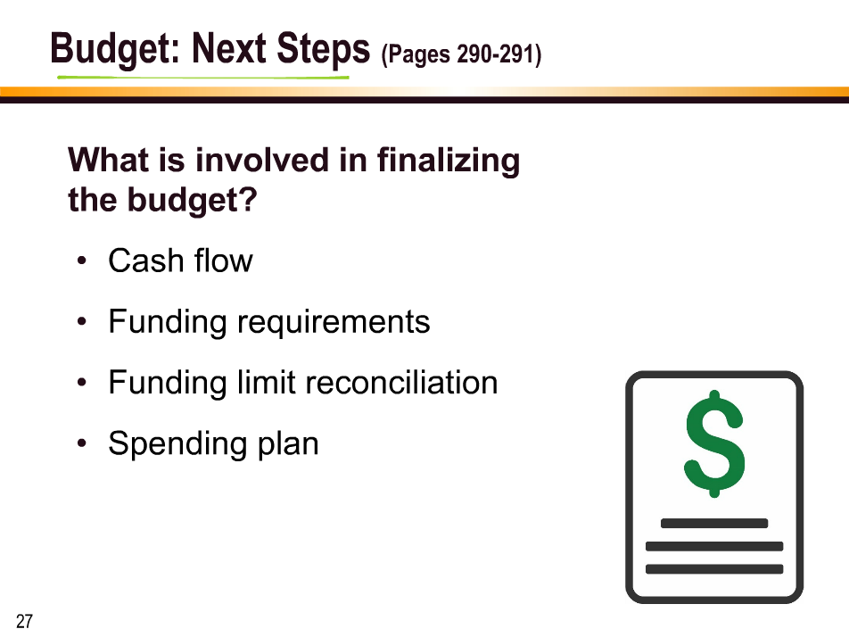

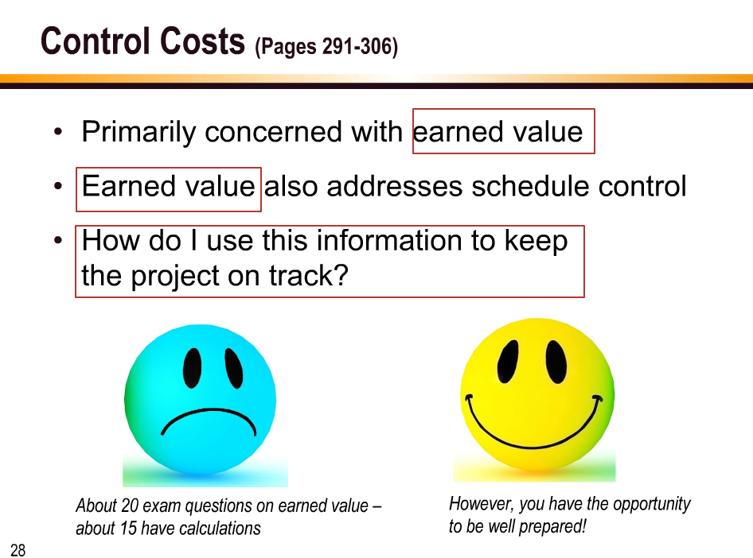

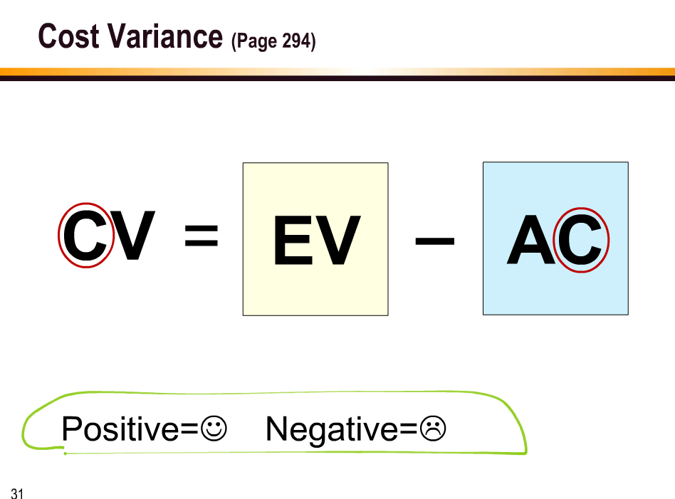

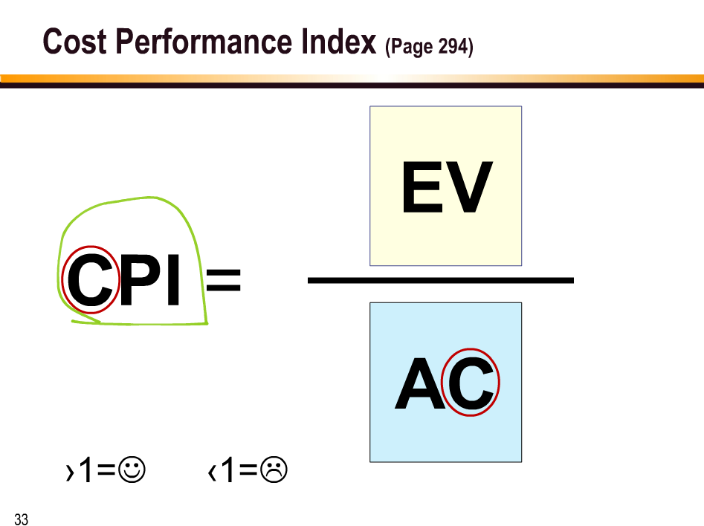

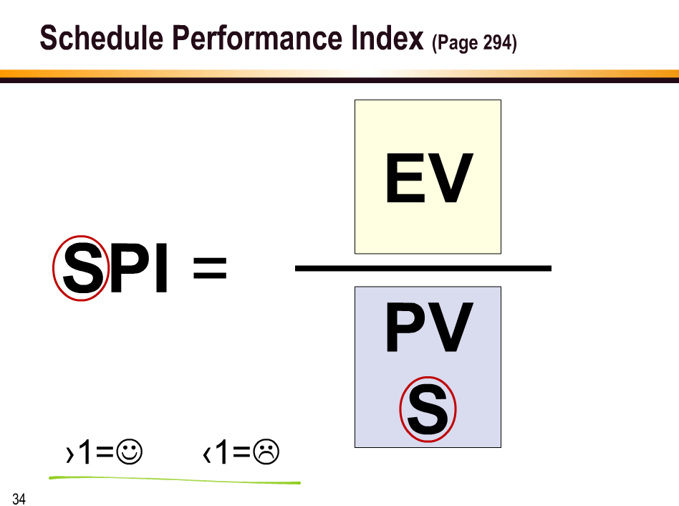

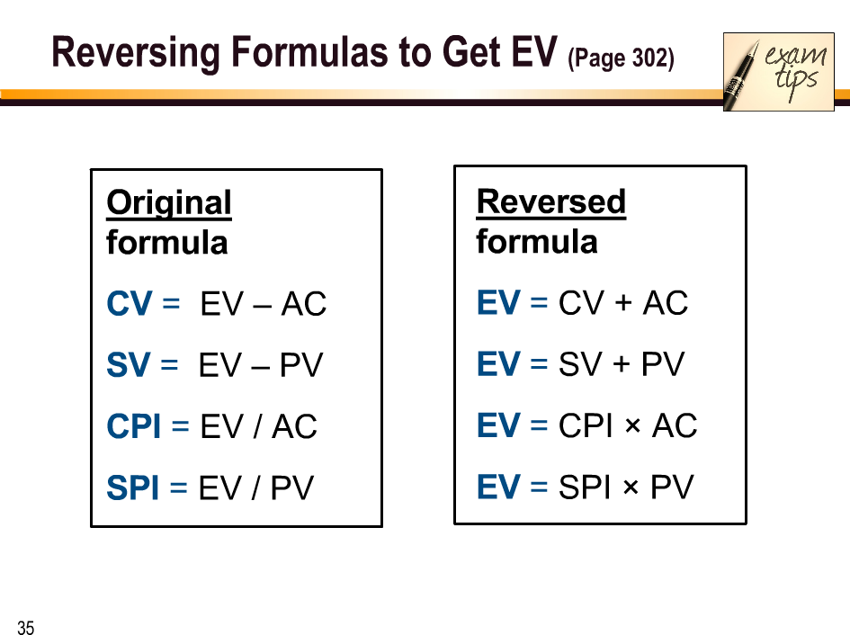

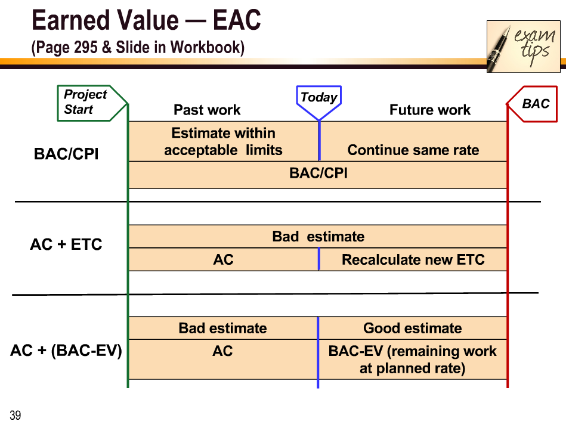

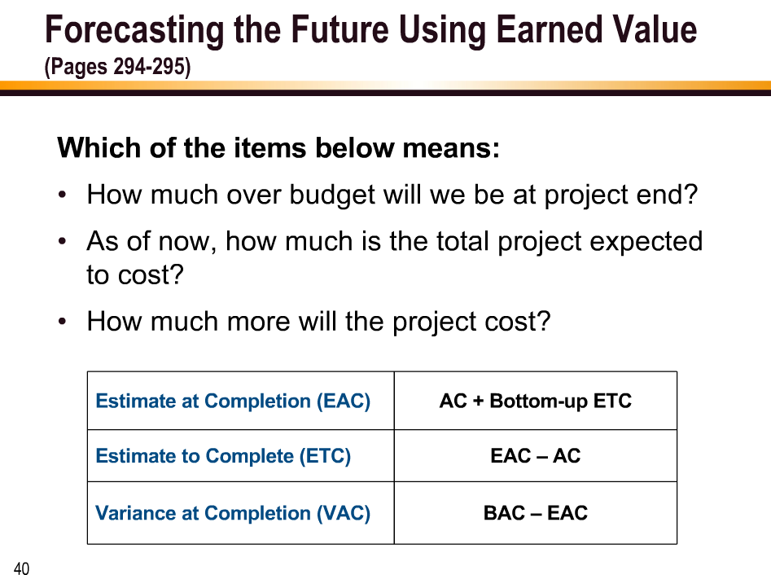

Ryan Ballew: sounds good, I'm at ballewr@gmail.com if anyone wants to reach out about a study group

Grace Sarkissian: grace.sarkissian@gmail.com

Amy Killian-Hemschoot: amy.killian@hotmail.com

Candace Caamano: candace.caamano@gmail.com

Clint Kelfer: [ckelfer05@gmail.com](mailto:ckelfer05@gmail.com)

Sending ‘Jump Start’ in two weeks

Margo Kirwin: Download sheet = Brain Dump

Grace Sarkissian: Will we get a Certificate of Completion for the course?

Margo Kirwin: So, your "dowload sheet" is just a blank sheet of paper that they will give you, and you have selected what you are going to put on it.

Margo Kirwin: You practice that as many times as possible before the exam.

Margo Kirwin: Certificates will be sent as soon as possible after this class.

Jackie Campbell: What subjects would you recommend for the brain dump - Contract types, theories, formulas, process chart, and ???

Margo Kirwin: Process chart in particular for Quality/

Margo Kirwin: Quality Tools is also an example

Margo Kirwin: Theories/Theorists - show up in Quality and Resources

Clint Kelfer: are there specific formulas to know more than others?

Margo Kirwin: PMI-isms are in Chapters 1, 15, aslo in Quality Chapter.

Grace Sarkissian: If we email students@rmcls.com, will we be able to contact you? Or will another instructor respond?

Margo Kirwin: Study your PMI-isms - meaning - all thsoe things that might be different from your real life

Margo Kirwin: Those "top 4" from today - Cv, SC, CPI, SPI

Clint Kelfer: ok, thanks!

Margo Kirwin: P 629 is your Formula Page